Your Task

Create a web application for browsing Rick & Morty characters.

The API documentation is located on this URL: [API Documentation](https://rickandmortyapi.com/documentation).

You should consume the REST API, **not the GraphQL version** of the API.

The web application should have a single grid view, displaying characters as cards (first 20 characters).

Character cards should display character’s image and name as well as a like button.

By clicking on a character card, the user should be presented with character details, showing all other fields of the character schema.

If communication errors occur, they should be presented to the user without breaking the usability of the application.

How you design and display any of the pages/components is totally up to you, but here some example how some other students did it.

Homepage (characters grid)

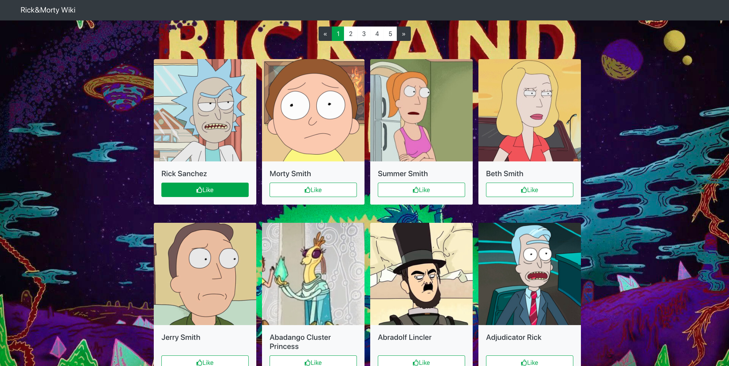

Character details



**Technical Details**

* Use ES6 modules